Supplementary material

The flowchart outlines the process used to select NSCs from patient visits to the emergency departments (EDs) of eight tertiary university hospitals. A total of 504,113 ED visits were recorded during the study period. After excluding 19,156 visits that were not for treatment or lacked documented reasons, 484,957 patient visits with chief complaints were analyzed. After removing duplicates, 5372 unique chief complaints were identified. From these, 264 NSCs were selected based on predefined criteria.
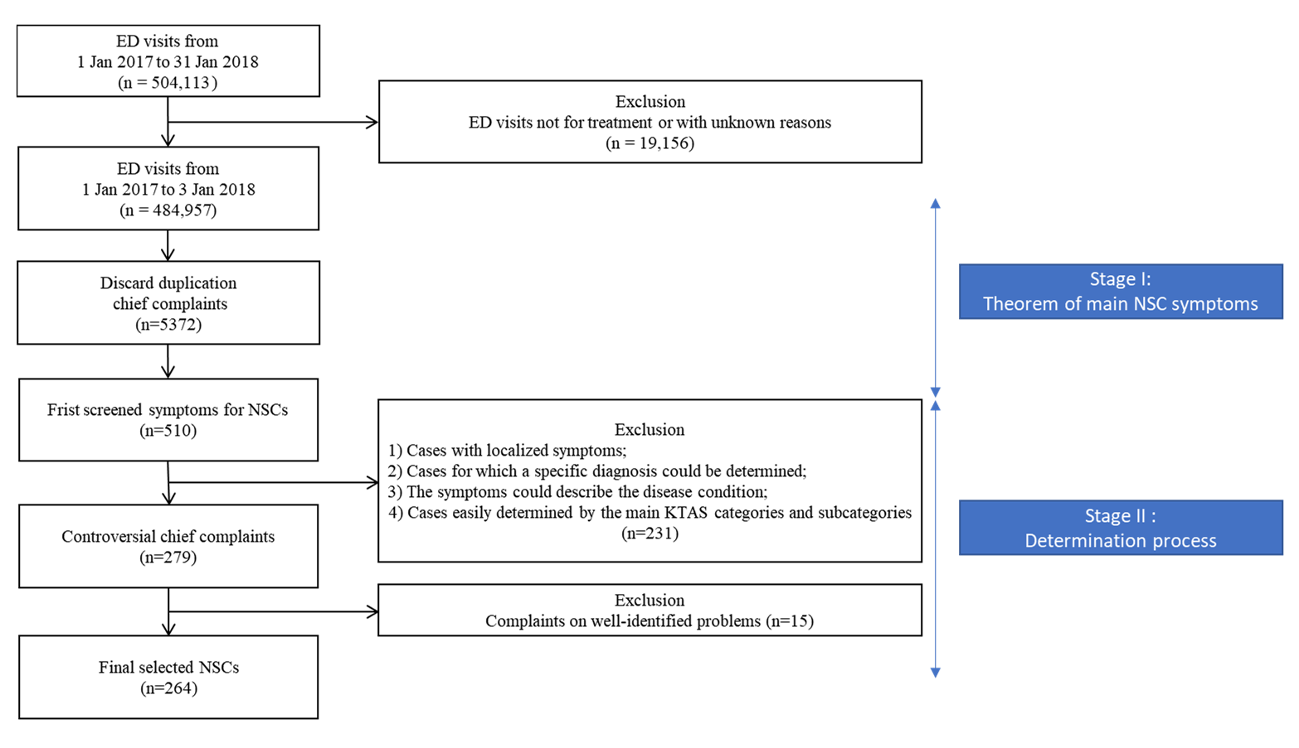
Supplementary Fig. 1. Flowchart of the selection process for non-specific complaints (NSCs) in the study. ED: emergency department.

